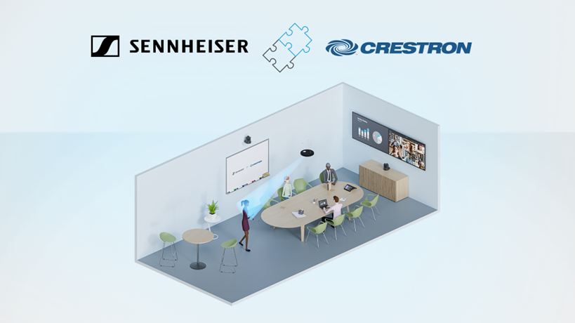

Sennheiser TeamConnect Ceiling Medium Now Supported by Crestron Automate VX

Valued strategic partner integrates Sennheiser’s latest ceiling microphone into multi-camera switching solution, driving more equitable meeting experiences

Wedemark, Germany, December 13, 2023 – Sennheiser, the first choice for advanced audio technology that makes collaboration and learning easier, is pleased to announce that its TeamConnect Medium (TCC M) ceiling microphone for mid-sized meeting rooms and lecture or collaboration spaces has been integrated into the Crestron Automate VX voice-activated speaker tracking solution.

Automate VX technology enables a high-quality meeting experience with production-style cuts across a variety of applications including corporate boardrooms, multipurpose spaces, and training rooms. The combination of TCC M and Automate VX technology leads to more inclusive meetings, especially for mid-sized collaboration spaces and lecture halls. High-quality audio and intelligent video technologies are vital to supporting a critical and dynamic collaboration experience.

With the Automate VX solution, multiple cameras around the room work together to track active speakers, while removing distractions that are typically visible when a camera pans, tilts, or zooms. As the conversation moves around the room, TCC M’s patented automatic dynamic beamforming technology ensures the speakers are continuously being heard.

With the integration of the complete Sennheiser TeamConnect Ceiling Family into Crestron's Automate VX technology and the Intelligent Video Designer software, integrators can now streamline the setup of larger systems, making the process more efficient and time effective.

"This exciting integration between Sennheiser’s TeamConnect Ceiling Medium and Crestron’s Automate VX brings optimum equity to meeting participants in meeting rooms, lecture halls, and collaboration spaces,” said Bob Bavolacco, director of technology partnerships for Crestron. “It provides a premium Sennheiser audio experience coupled with the unparalleled Crestron Automate VX multi-camera switching technology.”

Launched earlier this year, TCC M delivers all the innovation and features of the award-winning TeamConnect Ceiling 2 (TCC 2) to a new segment of the meeting space market. With a coverage area of up to 40 m², customers can now bring the power of TCC 2 to their mid-sized meeting space, with a sleek design and at an attractive price-point.

The TCC M offers the same ceiling installation options as the TCC 2, but in a round shape. It can either be surface-mounted, suspended, or flush-mounted, allowing for cable-free tables and flexible furniture arrangement.

“This integration with Creston’s Automate VX is a further example of the flexibility of the TCC M, a member of the TeamConnect Family Solutions,” said Charlie Jones, global alliance & partnership manager at Sennheiser. “It also demonstrates our commitment to working with our partners to deliver solutions that create inclusive and productive collaboration experiences, whether participants are in the room or joining remotely.”

For more information about Creston’s Automate VX solution, visit https://www.crestron.com/Products/Featured-Solutions/Automate-VX. To learn more about Sennheiser’s TCC M and the complete TeamConnect Ceiling Solutions. go to https://en-us.sennheiser.com/teamconnect-ceiling-solutions.

About the Sennheiser brand
We live and breathe audio. We are driven by the passion to create audio solutions that make a difference. Building the future of audio and bringing remarkable sound experiences to our customers – this is what the Sennheiser brand has represented for more than 75 years. While professional audio solutions such as microphones, meeting solutions, streaming technologies and monitoring systems are part of the business of Sennheiser electronic GmbH & Co. KG, the business with consumer devices such as headphones, soundbars and speech-enhanced hearables is operated by Sonova Holding AG under the license of Sennheiser.

www.sennheiser.com
www.sennheiser-hearing.com

Global Press Contact

Jeff Horan
+1 860-598-7539
jeffrey.horan@sennheiser.com

